- Why Black Litterman can improve?

The “standard” way of doing portfolio optimisation is to start with a group of assets from which you’d like to make a portfolio, construct a vector of expected returns (usually by taking the mean historical returns of a group), then feed this vector along with the covariance matrix into a mean-variance optimiser (MVO).

This sounds great in theory, except that the resulting portfolios tend to perform shockingly badly in practice, worse than if you were to just equally-weight the assets.

As it happens, the major cause of problems is the use of mean historical returns to estimate future returns. The Black-Litterman model attempts to improve on this by using a clever Bayesian scheme to construct the expected returns vector.

- Basic Idea of Black Litterman Model.

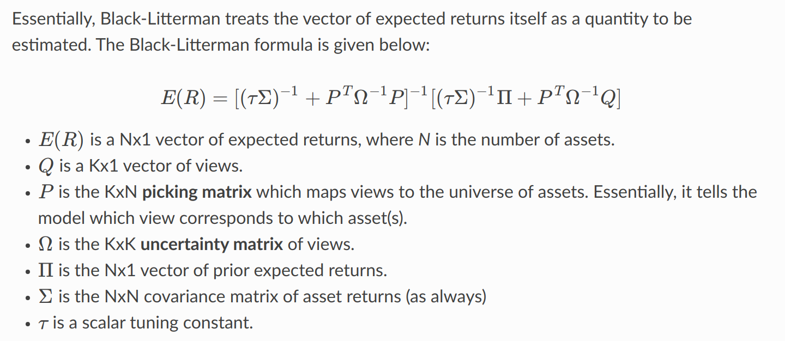

BL is a Bayesian model which essentially provides a way of combining your views with some prior estimate of returns

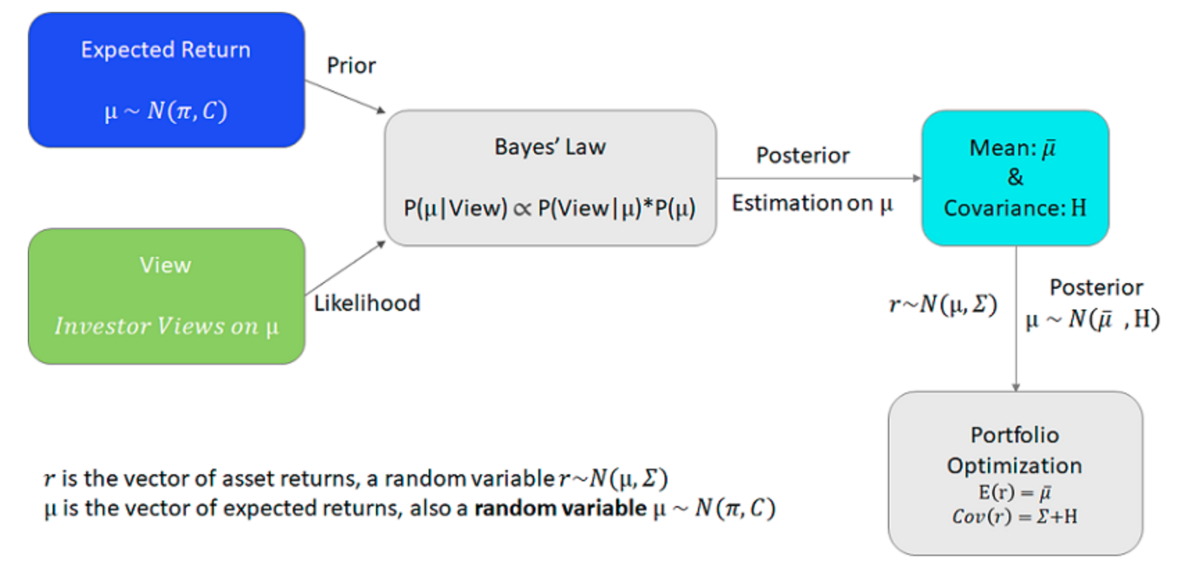

- View

A view is just a forecast you have of the future returns of an asset. It is different to the expected returns vector required by Efficient frontier optimisation

- Prior

Part of the insight of Black and Litterman’s 1991 paper was that the current market-capitalisations of stocks can be used to construct a reasonable prior estimate of returns.

For example, if company A has double the market cap of company B (assuming they have the same volatility), it can be argued that company A has double the expected return of company B.

Maybe this isn’t a great estimate, but it doesn’t have to be – it is just a prior, which we will later update with our sophisticated views.

